**Phase 3**

**Project Title:**Smart Public Restroom

Designing a smart public restroom involves integrating technology and automation to enhance user experience, improve hygiene, and optimize maintenance. Here's a step-by-step procedure to create a smart public restroom:

Creating a smart public restroom involves integrating various technologies to enhance user experience, promote hygiene, and optimize maintenance processes. Here's a step-by-step procedure to design and implement a smart public restroom:

**1. Needs Assessment:**

- Identify the location and expected foot traffic to determine the restroom's size and capacity requirements.

- Conduct surveys or research to understand user preferences and requirements.

**2. Design and Layout:**

- Design an efficient layout for the restroom, considering the placement of fixtures, entry and exit points, and accessibility for people with disabilities.

- Ensure proper ventilation, lighting, and use of eco-friendly materials for sustainability.

**3. Sensor Integration:**

- Implement occupancy sensors to detect when users enter and exit the restroom. This data can be used to manage cleaning schedules and resource utilization.

- Install motion-activated lighting to save energy when the restroom is not in use.

**4. Smart Fixtures:**

- Use smart toilets and urinals with automated flushing mechanisms to promote water conservation.

- Install sensor-based faucets and soap dispensers to encourage hand hygiene and reduce water wastage.

- Integrate smart hand dryers that adjust airflow and duration based on the user's hand movement.

**5. Hygiene Maintenance:**

- Implement a real-time monitoring system to track the restroom's cleanliness status.

- Use sensors to detect toilet paper and soap levels, triggering automatic reordering when supplies are low.

- Integrate self-cleaning technologies, such as UV-C light or antimicrobial coatings, to reduce the need for frequent manual cleaning.

**6. IoT Connectivity:**

- Connect all sensors and smart devices to a centralized Internet of Things (IoT) platform for data analysis and remote monitoring.

- Utilize IoT data analytics to optimize cleaning schedules, water usage, and supply replenishment.

**7. User Experience Enhancement:**

- Provide user-friendly interfaces, such as touchless control panels or mobile apps, to allow users to request assistance or report issues.

- Implement queue management systems to inform users about restroom occupancy and estimated wait times.

**8. Accessibility and Inclusivity:**

- Ensure the restroom is accessible to people with disabilities, incorporating features like wider stalls, grab bars, and low sinks.

- Implement voice-controlled devices or tactile interfaces for users with visual impairments.

**9. Maintenance and Support:**

- Train maintenance staff to handle smart restroom technologies and troubleshoot common issues.

- Establish a proactive maintenance schedule to prevent system failures and ensure a seamless user experience.

- Provide a support system for users to report technical problems or give feedback.

**10. Regular Updates and Feedback:**

- Collect feedback from users to identify areas for improvement and gauge user satisfaction.

- Stay updated with emerging technologies and trends to continuously enhance the smart restroom features.

By following these steps and staying mindful of user needs and technological advancements, you can create an efficient, user-friendly, and sustainable smart public restroom.

**Project description:**

A smart toilet, by definition, uses integrated technology and data to interact and connect with the user. It's designed to improve the hygiene level and personal cleansing experience. Moreover, it gives insight to stakeholders to save manpower & resources, and enhances safety, operations and customer experience.

The concept of modern smart toilets [**originated in Japan in the 1980s**](https://www.lifewire.com/what-is-a-smart-toilet-4628135)**.** Kohler released the world's first smart toilet named Numi in 2011, which allows users to set their ambient lighting, adjust the water temperature, and enjoy music with the built-in radio. Now, as technology marches forward, smart toilets have been hailed as the next big thing with more advanced functions and features.

These new modern toilets are part of China's efforts to implement AI into daily life and come hot on the heels of [smart bins](https://www.guardforce.com.hk/en/security-technologies/smart-bin) and AI-powered traffic lights.

There are many high-tech public toilets in Hong Kong tourist spots to overhaul conditions in the city's public conveniences. [Shanghai has also built around 150 smart public restrooms](https://www.scmp.com/tech/innovation/article/3033187/reading-book-shanghai-toilet-could-be-bad-idea-if-you-dont-want-be)to improve their tarnished image.

A smart toilet system is also a saviour for the organizations where they have to manage multiple toilets - it reduces manpower and keeps restrooms cleaner. The system can also assist cleaning companies in managing their staff and timetables effectively.

**IoT implementation:**

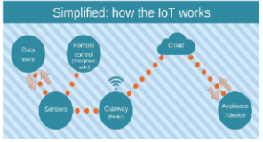

Sound sensor or mic sensor provides digital output and it detects sound from atmosphere. A WiFi module is also connected to Arduino and it is used to transfer data from the sensors to cloud server. ESP8266 WiFi module is used to store the data to online server. The data from sensor are basically analog signal so analog to digital converter (ADC) is used to convert the data. 16 x 2 Liquid crystal display (LCD) is used to display the measured value from the sensors. It can display two lines and each line has 16 characters.

**Methodology:**

The MQ-135 sensor detects the stench of the toilet. The presence of ammonia gas in the atmosphere is detected by this sensor. The presence of Ammonia is responsible for the toilet's foul odour. Ammonia has a pungent odour that can only be perceived at a concentration of 5 parts per million (parts per million).Fans automatically turn on when the ammonia content in the toilet exceeds the set threshold of 5 ppm, while levels below 5 ppm have no impact. Moving on to the next component, an infrared sensor is used to check for the presence of soap in the toilet.

**Block diagram:**

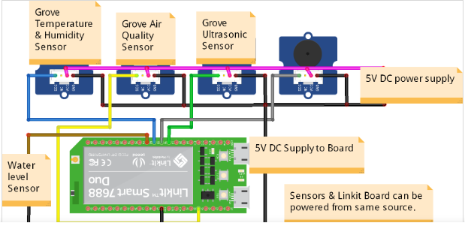

**Schematic :**

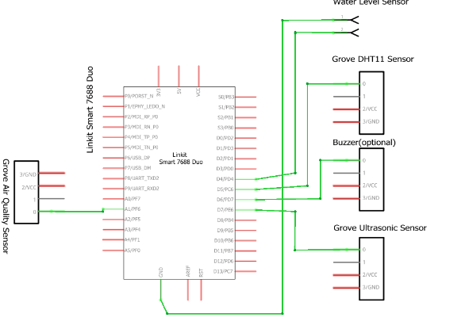

**App Development :**

As the app was created by using Visual Studio Code, the app will display the data takenfrom the sound sensor. Visual Studio Code is a software to create app use Python language todesign an Android development .Smart public toilet product solutions can monitor the temperature, humidity, odor and other environmental parameters in the public toilet through environmental monitoring sensors, and automatically adjust the temperature, humidity and ventilation system in the public toilet according to the parameters to improve comfort and hygiene.

**Benefits of using smart toilet:**

Improved Customer Satisfaction.

Optimized Cleaning for washroom.

Energy Saving with Optimized Heating and Air Conditioning.

Cost Saving in Inventory, Delivery, and Logistics.

**Conclusion:**

A rapid change of delivery and more rigid, developing conditions don’t need to lag your operations. With Faststream Technologies’s Smart Restroom solution, we’ll provide you with everything you need to digitize your [bathroom](https://www.faststreamtech.com/solutions/connected-smart-home-appliances/smart-bathroom-solutions/) and toilet operations and get the most out of your cleaning supplies, staff, and customer satisfaction.

We offer an integrated Smart Toilet Management system connected with the sensors, gateways, networks, and the cloud to get your data flowing into the software dashboard or platform. Our Smart Restroom systems will give data space usage or consumption of paper, hand wash, and soap in your washrooms along with smart toilet people counter.

Faststream’s smart restroom solution is ideal for client places such as large airports, shopping malls, stadiums, hospitals, and schools where large footfalls are common as it is able to identify any hygiene or operational issues, leaks or breakdowns, and send SMS alerts so your team can address the problem.

**App coding :**

**\\markdown**

smart_restroom_app/

|- templates/

|- index.html

|- app.py

**\\html**

<!DOCTYPE html>

<html lang="en">

<head>

<meta charset="UTF-8">

<meta name="viewport" content="width=device-width, initial-scale=1.0">

<title>Smart Restroom App</title>

<link rel="stylesheet" href="https://maxcdn.bootstrapcdn.com/bootstrap/4.0.0/css/bootstrap.min.css">

</head>

<body>

<div class="container mt-5">

<h1>Smart Public Restroom</h1>

<p>Status: {{ status }}</p>

<button id="occupancyButton" class="btn btn-primary">Toggle Occupancy</button>

<br><br>

<textarea id="feedback" class="form-control" placeholder="Provide feedback"></textarea>

<button id="feedbackButton" class="btn btn-success mt-2">Submit Feedback</button>

</div>

<script>

document.getElementById('occupancyButton').addEventListener('click', function() {

// Implement code to toggle occupancy status via AJAX request

});

document.getElementById('feedbackButton').addEventListener('click', function() {

var feedbackText = document.getElementById('feedback').value;

// Implement code to send feedback via AJAX request

});

</script>

</body>

</html>

**1.Choose the Hardware:** Select appropriate IoT sensors (occupancy sensors, cleanliness sensors) compatible with your requirements and communication protocols (such as Wi-Fi, Bluetooth, or LoRa).

**2. Set Up the Hardware:** Install the sensors in the restrooms and connect them to a microcontroller or IoT device capable of running Python scripts.

**3. Write Python Script:** Develop a Python script to read data from sensors and send it to the restroom information platform. Below is a basic example of how you might structure the script for sending data over Wi-Fi using the MQTT protocol (assuming you're using a library like paho-mqtt):

**4. Integrate with Restroom Information Platform:** Ensure your platform is set up to receive data from MQTT topics "restroom/occupancy" and "restroom/cleanliness". Handle incoming data appropriately on your platform.

**5. Implement Error Handling and Security (Optional but recommended):** Add error handling mechanisms in your script, implement security measures such as encryption and authentication, and handle network interruptions gracefully.

**6. Test and Deploy:** Thoroughly test the setup in a controlled environment before deploying it in public restrooms. Monitor the data flow and ensure the accuracy of sensor readings.

Remember, this is a basic example, and you might need to modify it based on the specific sensors and platform you are using.

Coding :

import paho.mqtt.client as mqtt

import time

import random

# MQTT Configuration

broker_address = "mqtt.broker.com"

port = 1883

topic_occupancy = "restroom/occupancy"

topic_cleanliness = "restroom/cleanliness"

# Simulated sensor data (replace this with actual sensor readings)

def get_occupancy_data():

return random.randint(0, 1) # Simulating occupancy data (0 or 1)

def get_cleanliness_data():

return random.uniform(0, 1) # Simulating cleanliness data (0 to 1)

# MQTT on_connect callback

def on_connect(client, userdata, flags, rc):

print("Connected with result code "+str(rc))

# MQTT Client

client = mqtt.Client()

client.on_connect = on_connect

# Connect to MQTT broker

client.connect(broker_address, port, 60)

# Main Loop

while True:

# Get sensor data

occupancy_data = get_occupancy_data()

cleanliness_data = get_cleanliness_data()

# Publish data to topics

client.publish(topic_occupancy, occupancy_data)

client.publish(topic_cleanliness, cleanliness_data)

# Wait for a few seconds before publishing next set of data

time.sleep(5)